APPENDIX A:
PHOTOGRAPHS TAKEN DURING JIV AT 24’’ OGODA/BRASS PIPELINE AT KALABILEMA IN BRASS LOCAL GOVERNMENT AREA OF BAYELSA STATE.

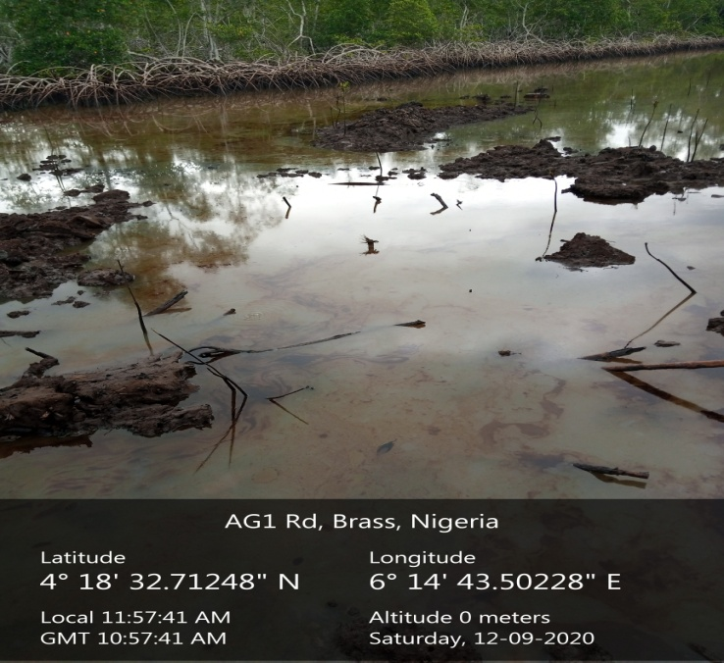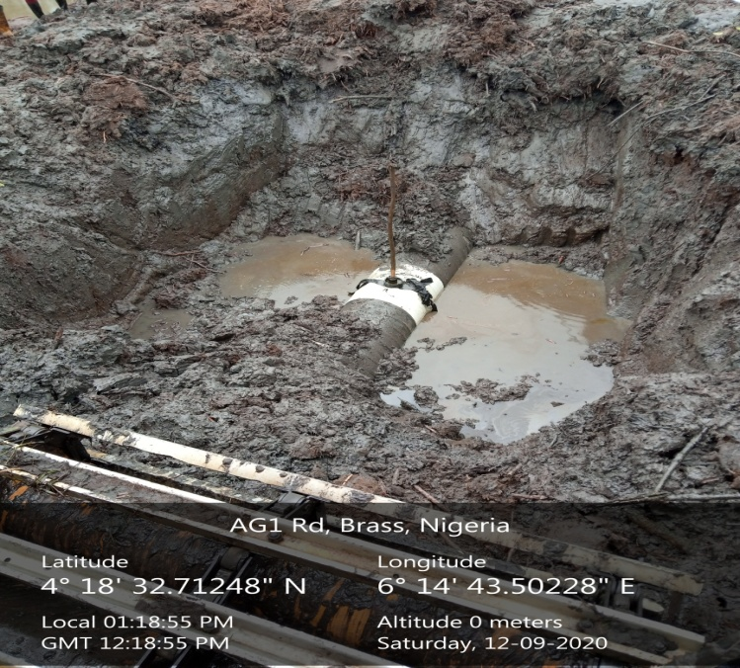
BEFORE EXCAVATION AFTER EXCAVATION (SPILL POINT)
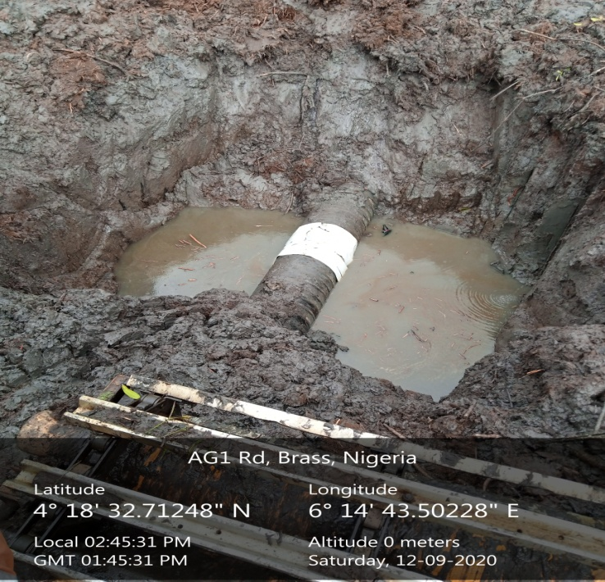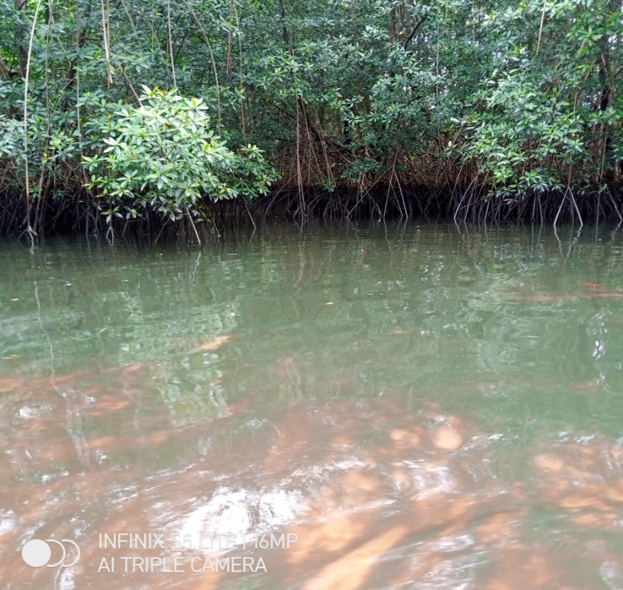
REPAIR POINT IMPACTED AREA

